# 风（Zephyr） GDD

Author: 夏嘉程 Jason Xia

Table of Contents

风（Zephyr） GDD 1

Change Log 2

Overview 2

Game Theme & Elements Related 3

Vision Statement 4

Similar Games & References 4

Gameplay Overview 4

Type of Game 4

Core Mechanics 4

Core Mechanic 1 4

Core Mechanic 2 4

Core Mechanic 3 4

Core Mechanic 4 4

Core Mechanic 5 4

Core Mechanic 6 4

Core Mechanic 7 4

Key Features 4

Victory Condition 4

Fail Condition 4

Characters & NPCs 4

Playable Characters 4

Enemies 4

NPCs 4

Items & Pick-ups 4

Pick-up 1 4

Pick-up 2 4

Levels Elements 4

Element 1 4

Element 2 4

Controls 5

Game Modes 5

Monetization 5

Interface / HUD 5

Camera System 5

Menu Layout 7

Art Style 9

Tutorial Sequence 9

Achievements & Rewards 9

Lite Version 9

Data to Log 9

Appendix 9

## Change Log

|  |  |  |
| --- | --- | --- |
| Date | Name | Details |
| 2/3/2024 | Created document |  |
|  |  |  |
|  |  |  |

# Overview

Walking in the depth of Hell, you are struggling to survive. You can feel the pressure in the air, the demons whispering in your head telling you to give up. But you can't, you know you have forgotten something that’s important. You tell yourself you must recover what you lost, but you are almost at your limits. The more you discover, the harder it becomes. But you keep telling yourself: Keep moving... Keep moving...

During your wandering, you found strange pieces scattered around. They record nothing but painful thoughts and memories, and they are getting into your head. As you move on, continuously pushing your limits, your thoughts start flying. You can't help but think about why you got here. Everything felt so unreal, everything felt like a bad dream, and the only things you know are pain and misery…

## Game Theme & Elements Related

(Before reading this part, it is recommended to read Appendix 4)

The main game theme is about all the difficulties, negativity, and hardships in real life. If people get engulfed in these negative thoughts and such, they might get depression or other mental illnesses. This leads to suicidal thoughts, for which some can overcome, but some get defeated by it and leave the world. The main story is implicit, but as the player proceeds with the game experience, they will realize the truth of the world.

Explaining the setting: The player got teleported into this world remembering nothing, and the only way to go is forward. The player hears a voice claiming to be a goddess Alothai, who will guide him through the journey. Then they encounter enemies in the shape of monsters and demons. The player keeps on going, and each time the player dies, they remember something. What they remember is related to the enemy that killed them. This basically is the rediscovery of the player’s life before reaching this realm. For example, if the player died in an early level, killed by a demon that represented loneliness, what happens after the death is that some stat of the player decreases indicating that they were beaten by some sort of hardship. This is also why I implemented a lot of stats. Because as people we have a lot of qualities, and these qualities may decrease or vanish as we grow up and go through different things. Each stat implicitly stands for a certain quality. After the player dies, a sentence could be shown on their screen. Something like: upon this death, you suddenly remembered something. It was in primary school. You were sitting alone in the corner, looking at classmates playing with each other. But there was no one around… There is no explicit life limit. Whenever a potential stat drops below -10, the game is over immediately, and something may appear on the screen: You remembered more… (Something happened) ... (What you felt) ... You finally had enough. GAME OVER. Also, as the player proceeds through the game and defeats enemies, there is a chance the enemies will drop memory fragments of other people. These fragments will be more thorough and clearer. Explorers may like this kind of collecting stuff, and they could also be linked to achievements. If the player wins the game, the output will be different. Based on how many times the player died, the result will differ. for example, if the player only died once as the first example is, something can be displayed on the screen, like: you remembered more… you see a girl/boy(doesn’t matter) running towards you. “Come play with us!” You open your eyes and see yourself in a hospital. Someone is sitting beside you. It was a fever dream after all. You smiled and went back to sleep. This could be the ending for someone who died the most to demons that represent loneliness. If someone died the most to “stress”, they might wake up on vacation, etc. Just some thoughts on the background. It would be best if these texts could be accompanied by pictures illustrating each sentence, and for deaths black and white pictures, but for successful colored ones.

One major element of the game is wind, as the game name “风” (Zephyr) means. There are many reasons for this. One is that this game is in memory of a lost friend who died of suicide. “风” was part of his name. Also, wind can be warm or cold; can be soothing or harsh. We all need a gentle, mild breeze amid the violent tempestuous reality we call life. The abilities in the game will be mainly related to wind, including but not limited to blizzard, breeze, fire storm, etc.

# Vision Statement

What is the goal for this game? Who is it for? What kind of game is it?

Main goal is to finish all three stages of the game without losing all lives. The game is mainly for achievers and explorers, but killers might also find certain aspects challenging.

For achievers, the game will incorporate achievement systems including but not limited to normal achievements (finishing the game, defeating every type of enemies, single life victory, etc.), but also hidden achievements obtained by chance when the player defeats a certain enemy.

For explorers, I will give certain enemy types a chance of dropping items unrelated to the game process but the background story. These stories will incorporate the main theme in a fragmented and implicit way. Collecting full sets of these notes will unlock hidden achievements.

For killers, the game can be very hardcore. Upon entry, the player can define potential stats and the difficulty of the game experience. Difficulty determines the stats of the enemies and also the total number of potential points the character has. Potential is directly correlated to the number of lives the player can use up, and the lower the player’s potential, the lower the player’s numerical stats and the effectiveness of augments are. With these aspects combined with some touch of the numerical stat values of the enemies, the game can be very hardcore.

As said, this is a roguelike game, which is known for its unpredictability due to many intertwining aspects affecting the actual gameplay. However, to my knowledge, no roguelike game has such a complicated stat system as MOBA games. Therefore, I decided to implement a complicated stat system in a roguelike game, and make the stats closely intertwined with the gameplay experience, giving a wider variety of combinations for the player to explore. Also as for the repeating feature of roguelike games, In the lobby the player will be controlling Alothai instead of the human soul. There she can use the resources gained by previous runs to give more power to the next soul she takes over. It can be used to buy and upgrade skills, weapons, and base stats of the player in the runs.

# Similar Games & References

Hades, Dead Cells, other roguelike games

Damage and Stats inspired by LOL

Skills system similar to Bleach Vs Naruto

# Gameplay Overview

## Type of Game

Roguelike

## Core Mechanics

### Core Mechanic 1

Jump: advancing height. Can double jump in air

### Core Mechanic 2

Run: Increasing speed when moving can be used to shorten the distance, at a cost of stamina

Both in air and on ground

### Core Mechanic 3

Shift walk: decrease speed when walking, make no noise to approach enemies

On ground only

### Core Mechanic 4

Crouch: lower hitbox

On ground only

### Core Mechanic 5

Run shift: Increasing speed when moving without sound, can be used to shorten the distance, at a cost of stamina.

On ground only

### Core Mechanic 6

Roll: a burst of speed to a certain direction at a cost of stamina, undamageable during state

On ground only

### Core Mechanic 7

Dash: a burst of speed at a certain direction at a cost of stamina, lower hitbox

In air only, one chance each time in air

## Key Features

## Victory Condition

Finish the three stages without depleting lives

## Fail Condition

Lives depleted

# Characters & NPCs

## Playable Characters

Alothai: Goddess of Memory and Reality, the Teller of Tales, what the player plays between runs to get upgrades and such.

Random Human Soul: Led by a piece of Alothai’s consciousness, what the player plays in runs.

## Enemies

Any kind of enemies in any religion or mythology. Bosses for example could be mythic figures like Satan or even the great old ones on Cthulhu Mythos

## NPCs

Make some up that works under Alothai, could be related to wind and elementals, as source of powers of the player. Makes sense since Alothai is the goddess who weaves memories, and wind brings stories. Alothai’s setup could be a goddess who adores wind.

# Items & Pick-ups

Specific items are not designed yet, but the more powerful the rarer they are. As the items with common rarity, they could be usual weapons like bows and swords with different sizes or types. Adding up to that are elemental weapons, which could be of rare rarity. Then epic ones could be artefacts mentioned in mythos but not that powerful. For example, the ones used by demigods in Greek mythos. Then Mythic items, the items used by minor gods in mythos or weak ones used by major gods. For example the Cornucopia as in Greek mythology again. Then the legendary ones will be the main artefacts used by main gods. For example Poseidon’s trident. I only used examples from Greek mythology but there could also be artefacts by other mythologies and such.

## Pick-up 1

## Pick-up 2

# Levels Elements

## Element 1

## Element 2

# Controls

WASD for movement; W to climb, S to jump down

Double click WD to run

Space to jump

Shift to shift walk

Ctrl to roll

C to crouch

Scroll wheel to switch weapons

Click to fire

QERF for abilities

V for interaction

# Game Modes

Adventure mode, like the ones in usual roguelike games. Players define their character’s potential values and game difficulty, then start the game experience like any other roguelike game.

# Monetization

Defeating enemies gains you coins, and coins can get you weapons in shops. Otherwise weapons can only be randomly obtained from chests. In game coins are transferred into elixir upon finish, and there are augments and chests on the way to increase this number.

# Interface / HUD

<https://www.figma.com/file/WfDAzjTUSQF6BIIcSYU5tV/Zephyr-UI?type=design&node-id=0%3A1&mode=design&t=rs6VAa4vH3J9ZsoX-1>

# Camera System

(Section only for camera placement, ignore the UI on the example images)

Usual:

Going left then character on the right 1/3 of screen, and vice versa.

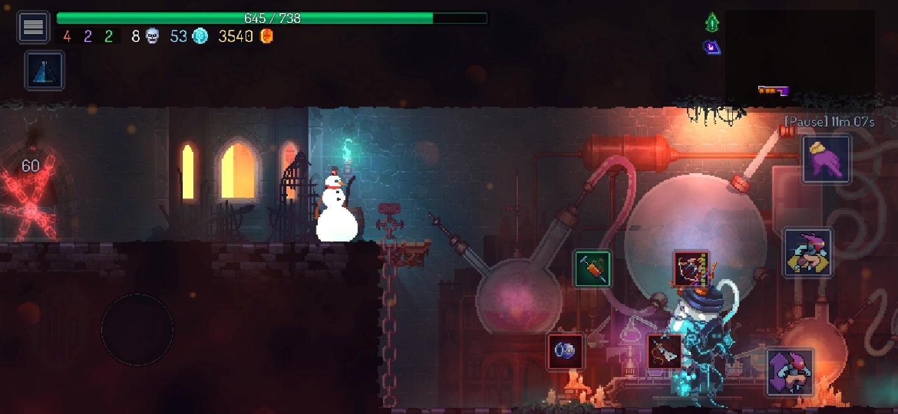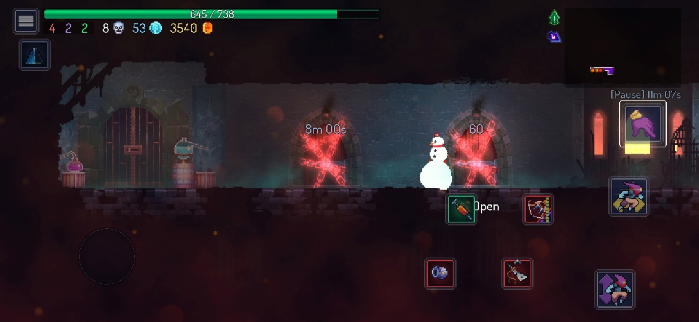

Boss Fights:

Far away then get camera further to include both.

Close up then there is a threshold height for the camera.

The mid-point between the two characters should also be the midpoint of the screen.

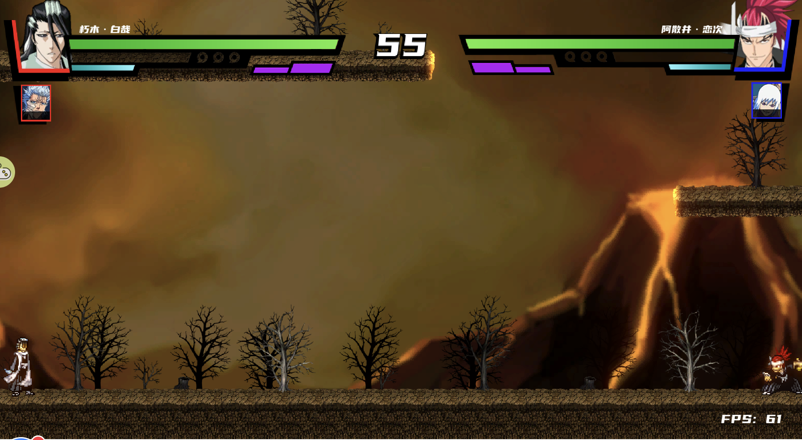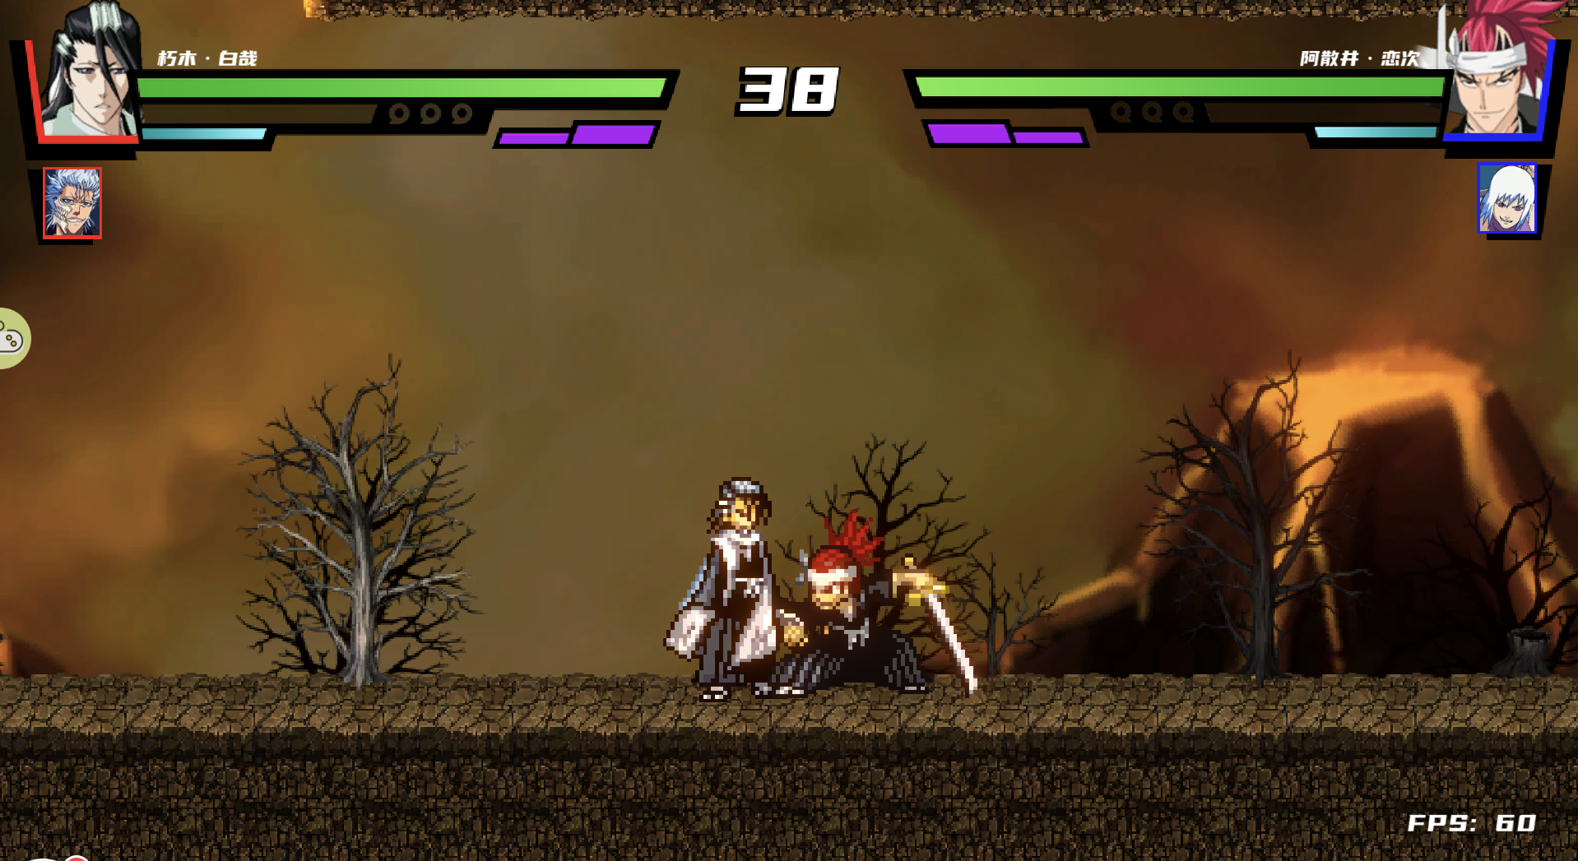

# Game Structure

**Interactions:**

<https://lucid.app/lucidchart/13ae581e-f20e-4e82-b5cb-1ac7c24ab913/edit?viewport_loc=-743%2C-217%2C4352%2C1959%2C0_0&invitationId=inv_86ec8d35-78a2-441d-9e9e-cc399f9c6bbb>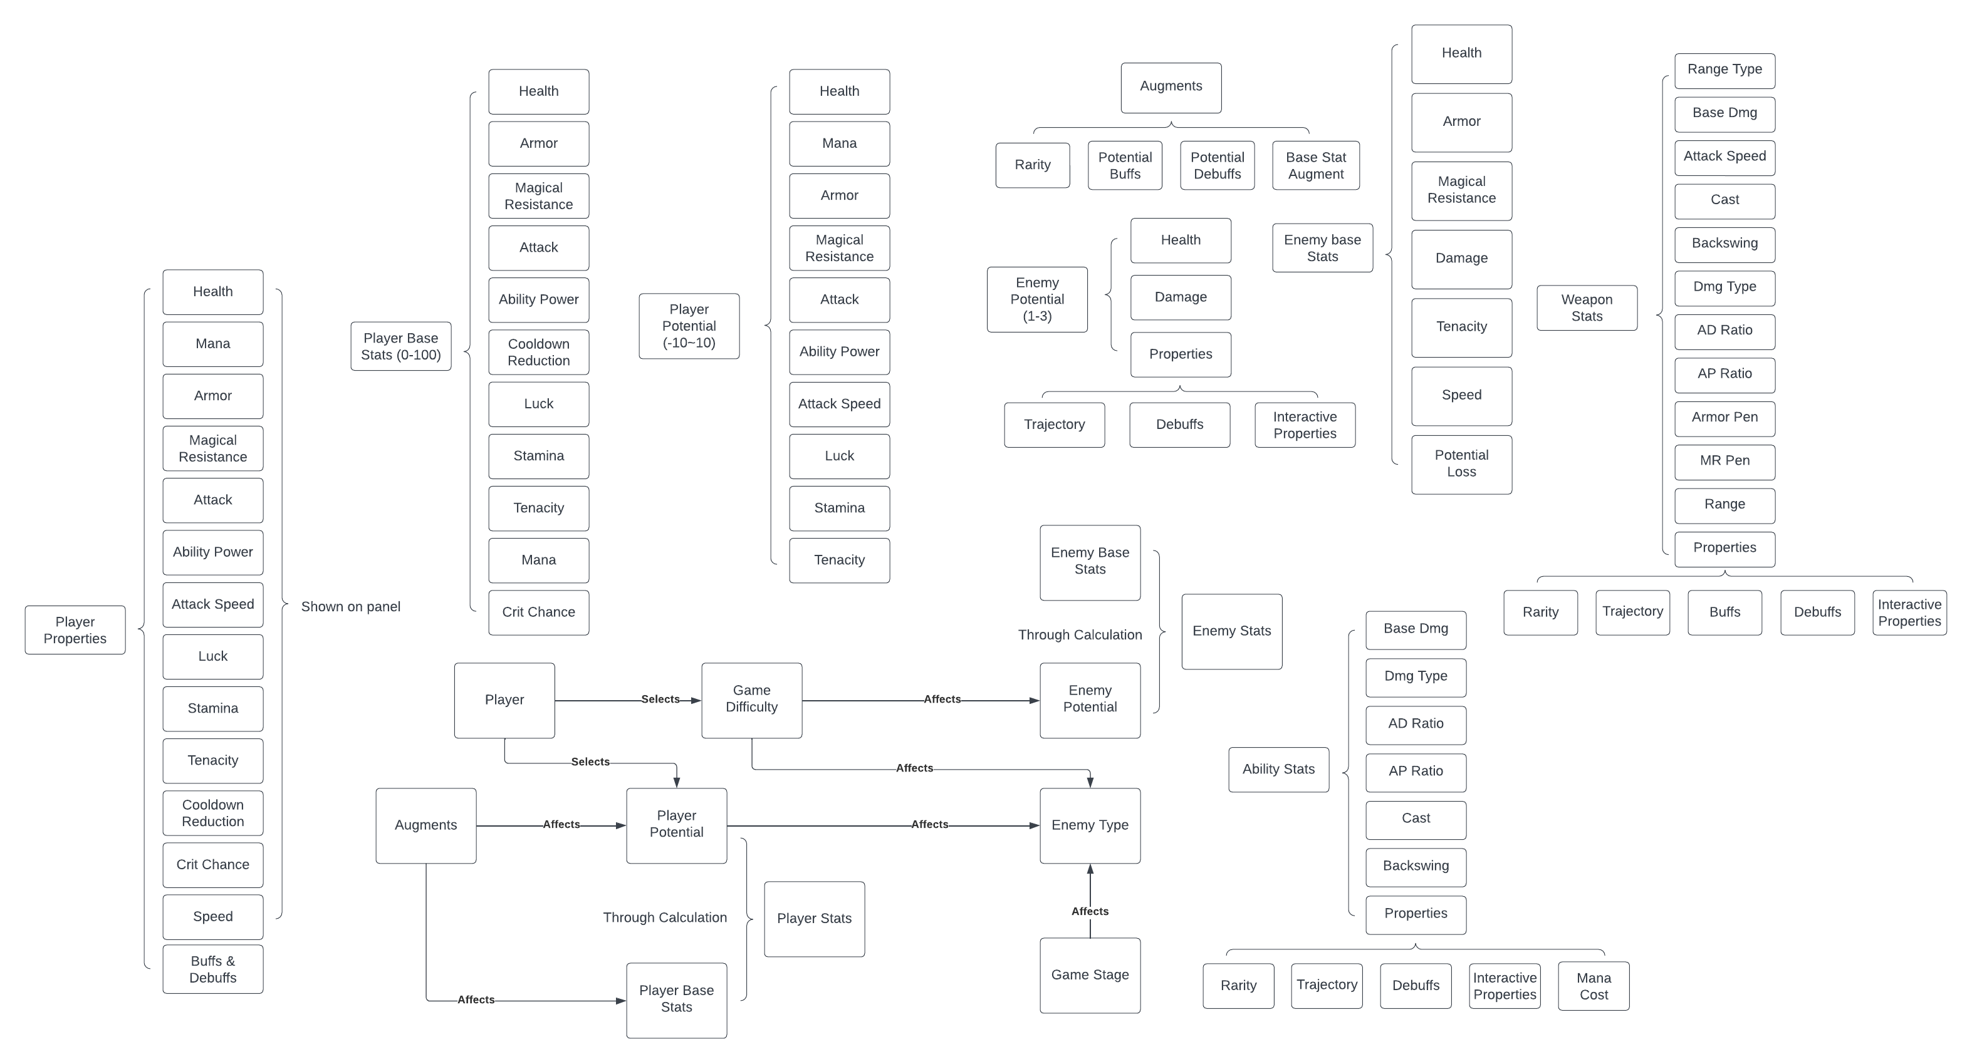

**Properties:**

Health(HP): Damage value object can take before death

Mana(MP): Resource for casting abilities

Armor(AR): Reduces physical damage

Magic Resistance(MR): Reduces magical damage

Attack(AD): Stats that boost physical damage

Ability Power(AP): Stats that boost magical damage

Attack Speed(AS): Stats that shorten cast and backswing

Luck: Stats that increase the chance of getting epic, mythical, legendary rarity items, skills, and augments

Stamina: Resource for rolling, running, etc.

Tenacity: Stats that decrease the time of CC

Cooldown Reduction(CDR): Stats that reduce cooldown

Crit Chance: Chance of dealing extra damage

Speed: How fast the object moves on the map

Trajectory: How the attack takes place

Interactive Properties: Knock-ups, Interactions with skills, etc.

Rarity: Common, Rare, Epic, Mythical, Legendary

Augments: Increase a certain aspect of base stat and potential, at the cost of some other potential

Enemy Type: Being killed by a certain enemy results in some loss of a certain potential

**Calculations:**

PlayerStats(x) = PlayerBaseStats(x) * (1 + PlayerPotential(x) * 5%)

EnemyStats(x) = EnemyBaseStats(x) * (1 + EnemyPotential(x) * 30%)

WeaponDamageDealt = ((PlayerStats(Attack) * WeaponStats(AD Ratio))% + (PlayerStats(AbilityPower) * WeaponStats(AP Ratio))%) * WeaponStats(BaseDamage) * (1 - (EnemyStats(Armor/MR)% * (1 - WeaponStats(Armor/MR Pen))))

AbilityDamageDealt = ((PlayerStats(Attack) * AbilityStats(AD Ratio))% + (PlayerStats(AbilityPower) * AbilityStats(AP Ratio))%) * AbilityStats(BaseDamage) * (1 - (EnemyStats(Armor/MR)% * (1 - WeaponStats(Armor/MR Pen))))

**Overall Procedures:**

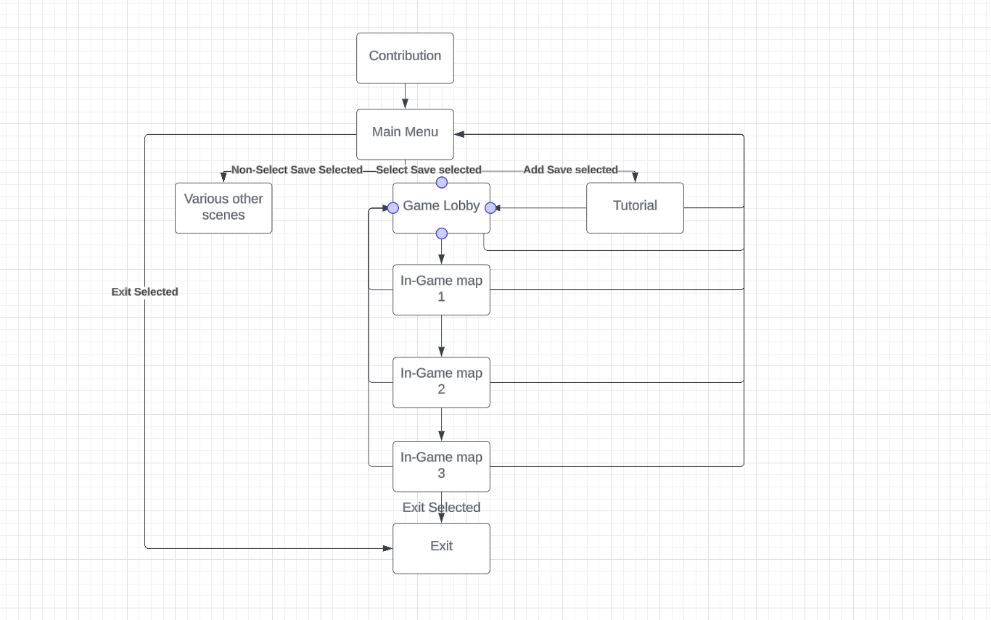

# Art Style

In-game art style is like dead cells, but map design will be more open.

CG art style is not sure yet but visioned to be like cartoons.

# Tutorial Sequence

Separate tutorial level forced upon player during first entry of the game.

Order the same as shown in controls

Player controls Alothai on a quest to defeat another immortal being. First you are outside of a castle going through the woods. Experience WASD through obstacles in the woods. First AD to move left and right, then double click to run. Reach a boulder forcing player to jump, reach a fallen tree forcing player to crouch. Find a hut with a chest inside, forcing player to interact and obtain a weapon. Then player can use scroll wheel to change weapons. Reach a sentinel tower prompting the player to shift walk. If followed, can successfully get to a rope where the player can climb. If not, 10 minions will come out. Player can easily beat them but needs time. On the tower a minion stands. Defeat the minion can see a trapdoor and player must press S to get down. After that enter a castle with another God, let’s say Zeus. Confront him on the war of the gods, saying stuff like it has gone too far and beat him. Player has no health bar so is invincible. Prompt the player to use QERF for abilities.

Tutorial Design: 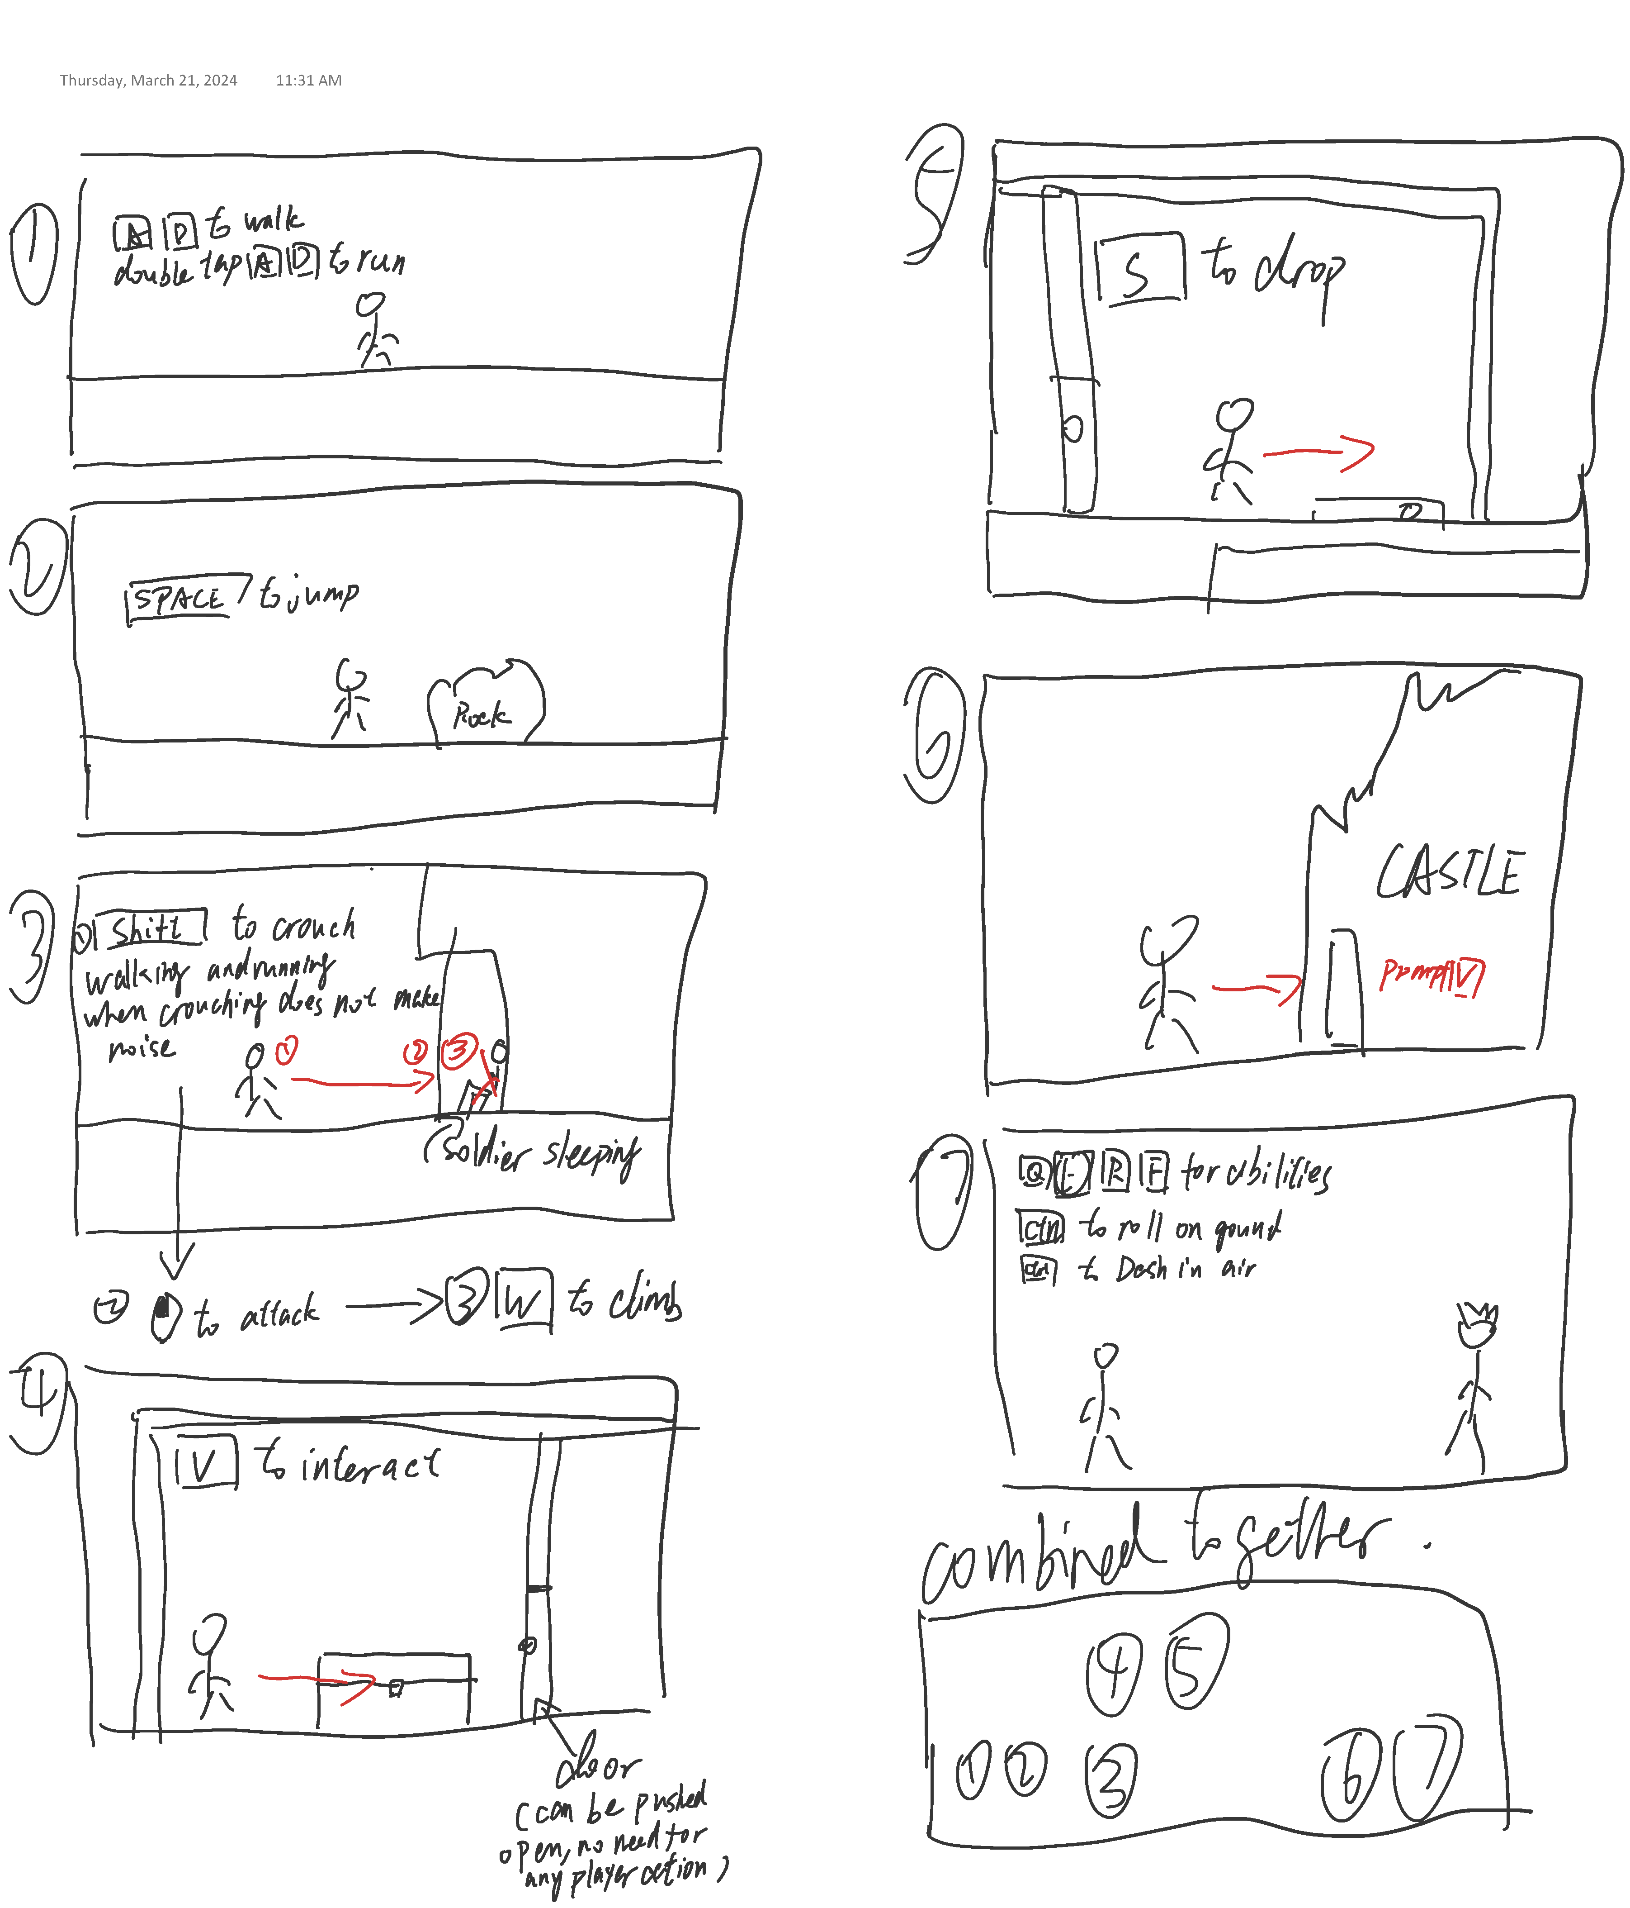

(Don’t mind my epic drawing:)

Tutorial elements:

***Weapons***

**Rusty Sword:**

Class: Sword

Type: Melee

Base Dmg: 10

Atk speed: 2/sec

Cast: 0.15s

Backswing: 0.3s

Dmg type: AD

AD ratio: 10%

AP ratio: 0%

Armor Pen: 0%

MR Pen: 0%

Range: 1

Rarity: Common

Trajectory: Inherit from Sword class

Knockback: Inherit from Sword class (1)

Buffs: None

Debuffs: None

**Bow of the Wind Elves:**

Class: Bow

Type: ranged

Base Damage: 20-50

Atk speed: 1-3/sec

Cast: 0.2s

Backswing: 0.1s

Dmg type: AD

AD Ratio: 20%

AP Ratio: 5%

Armor Pen: 10%

MR Pen: 0%

Range: 3-10

Rarity: Rare

Trajectory: Inherit from Bow class

Knockback: Inherit from Bow class(0.5)

Buffs: Player movement speed + 10% while holding

Debuffs: None

**Gungnir:**

Class: Spear

Type: Melee

Base Damage: 200

Atk Speed: 3/sec

Cast: 0.1s

Backswing: 0.2s

Damage Type: AD

AD Ratio: 50%

AP Ratio: 30%

Armor Pen: 30%

Range: 2

Rarity: Legendary

Trajectory: Inherit from Spear class

Knockback: Override, 0

Buffs: None

Debuffs: When hit an enemy the enemy is stunned for 0.3 seconds

***Characters***

**Alothai**

Health: Infinity

Mana: Infinity

Armor: 0

MR: 0

Attack: 1000

AP: 1000

Luck: 0

Stamina: Infinity

Tenacity: 50%

CDR: 50%

Crit chance: 0%

Speed: Run 10, Walk 6

Buffs: None

Debuffs: None

Weapon: As pickup

**Tired Soldiers**

Health: 20

Armor: 0

MR: 0

Tenacity: 0

Speed: 3

Potential Level: Depends on difficulty

Weapon: Rusty sword

States: Sleeping, Running, Walking, Attacking(Cast, Impact, Backswing), Idle

**Odin:**

Health: 2000

Armor: 100

MR: 50

Tenacity: 20%

Speed: 5 when walking, 10 when running

Potential Level: Depends on difficulty

Weapon: Gungnir (The Spear of odin)

Abilities: TBD

States: Idle, Running, Walking, Attacking(Cast, Impact, Backswing), Casting

# Achievements & Rewards

A list of achievements and unlockable rewards.

# Lite Version

Description of lite version

# Data to Log

# Appendix

The appendix should contain links to other related documents.

1. Sound List

2. Asset Lists

3. Level List

4. Story Description

"In the whispers of the zephyr, I hear the echoes of forgotten tales, the fleeting breath of memories yet untold."

* Alothai

Since the beginning of time, Alothai, the goddess of memories, has been weaving the tapestry of memories of the creatures of the realm the gods created. She would separate a bit of her consciousness, send it to the mortal world, and attach it to mortals. Then when the mortal is sleeping, she would then lead the mortal’s soul back to her and extract their memories. She would then return it to their bodies as if nothing had ever happened.

However, a battle of the Gods broke out. It lasted for millennia. After the fight, almost every god died, and the others to a long slumber, which nobody knows when they will wake. Artifacts are scattered and lost, glories of the gods long forgotten. The result of this is that the dark lords once kept at bay by the Gods became free. They seek to rule the world and reality as whole, but Alothai was too strong for them to defeat. They started to try to prevent Alothai from obtaining memories by surrounding Her and attacking the mortal soul Alothai has obtained. If the soul was beaten by the dark entities, they would alternate the memories of the soul and leave only the bad memories. Alothai was forced to increase the strength of the consciousness given to the human so that it can guide their soul to reach Her. She even gave out some of her abilities to ensure this, because she knows that reality is, but a reflection woven from the threads of memory only, and altering memory is to alter the very fabric of reality itself.